

January 2025

Dear Duty Bearers,

Welcome back and a Happy New Year to all! We hope that you had a fabulous Christmas holiday with your children. Mrs Hudson, Mrs Redman and myself would like to say a huge thank you for your thoughtful cards and gifts. We are now looking ahead to a busy and productive 2025!

The theme this term is **‘Traditional Tales’** and part way through the term we will have a week focusing on **Luna New Year** which is celebrated on the 29th of January. This year it is the Year of the Snake. We will of course continue to learn about seasons using our real-life experiences of **Winter** such as going on winter walks and exploring ice in our outdoor area.

**Traditional Tales**

 The children will be listening to a range of stories such as The Gingerbread Man, The Three Little Pigs, The Three Billy Goats Gruff and Goldilocks and The Three Bears, as well as any other traditional stories the children show an interest in. They will act out and recreate the stories using masks, puppets and a range of props. We will discuss where each story is set and how each character is feeling at different points in the story. We will compare different versions of each

story to see how details and endings sometimes change.

Activities will relate to each story and include building bridges out of different construction materials for the three billy goats and creating story soundtracks using different musical instruments. Our role-play area is based on ‘Once upon a time’ and has various fairy tale costumes for the children to create their own stories and act them out.

**Luna New Year**

We will locate England and China on maps of the world and consider how to travel between the two places. We will explore the country and culture of China by finding similarities and differences with our own surroundings and lives. The children will enjoy exploring Chinese food and customs as well as learning about how Chinese New Year is celebrated. In addition to this, the children will take part in a series of art lessons that finish with them creating their own monoprint.

**Read, Write Inc.**

The children are doing very well with their reading (keep practising at home!). We will continue to practise reading and spelling words with three or four sounds in them. We are encouraging the children to ‘Fred in your head’ and read words on sight. They are learning to read and spell more red words from memory. We will also reinforce writing in sentences using capital letters, finger spaces and full stops. We are encouraging the children to ‘have a go’ when writing independently.

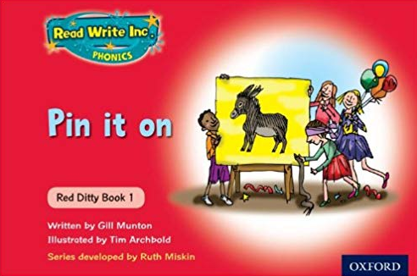

**Reading at Home**

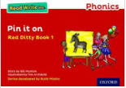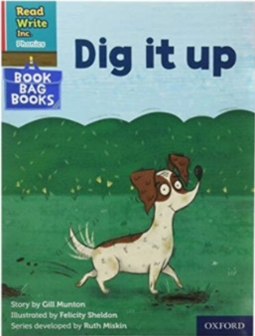Some of the children are now in the Red Ditty group and will bring home a paper copy of the book they have been reading at school along with a linked Book Bag book on a Friday to read to you. Their books will be changed every Thursday. We encourage the children to read their books at least twice as each time they will become more fluent.

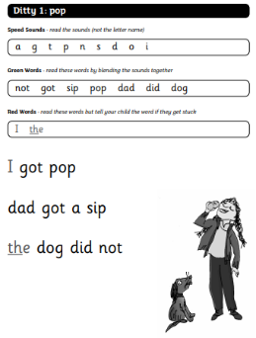

If your child is not yet in the Red Ditty group (there is no rush and every child is different) they will either bring home a Purple Blending Book or a photocopied ditty sheet to practise with you. I will also add video links to Tapestry for children to watch as needed. Please ensure your child has their books in their bookbag at all times and remember to write in their home school diary when they have read to you.

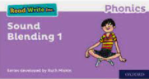

If your child cannot yet read three letter words using

Fred Talk e.g. m-a-t then keep practising. You can say

the sounds for your child and see if they can hear the

word.

**Number and Numerical Patterns**

During this term the children will consolidate their understanding of number bonds to 5. They will learn to read, write and order the numbers up to 8 and say what is one more or less than a given number. They will also continue to consolidate their understanding of addition by combining two groups. The children will explore capacity and mass by comparing amounts using key vocabulary such as light, heavy, full, empty, nearly full, nearly empty, smaller, smallest, larger, largest, most, least, etc.

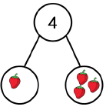



**Tapestry**

I hope you are enjoying seeing what your child has been experiencing at school. We love to see what your child has been doing at home too. We would encourage you to add your own observations to your child’s account. You can write a note, add a photo or upload a video. If you need any help with this please ask.

# PE

# PE this term is gymnastics and children should come to school in PE kit on a Friday for their usual PE session in the hall.

Thank you for all of your support. We hope that you and your child have a great third term. Please do not hesitate to come and see us with any queries or concerns, no matter how small.

# The Foundation Stage Team

**Mrs Ellis, Mrs Hudson and Mrs Redman**