Autumn 1  Topic: The Vikings | Autumn 2  Topic: Space | Spring 1  Topic: Coasts | Spring 2  Topic: The Victorians | Summer 1  Topic: The Victorians | Summer 2  Topic: The Ancient Maya
Fiction:  Beowulf, Michael Morpurgo  Arthur and the Golden Rope, Joe Todd Stanton  Non-Fiction:  The Vikings: Raiders, Traders and Adventurers!  Poetry:  Beowulf (kenning) | Fiction:  Cosmic , Frank Cottrell-Boyce  Curiosity: The Story of a Mars Rover  Non-Fiction:  Hidden Figures: The True Story of Fur Black Women and the Space Race  Look Inside: Space  100 Facts about Space  Tim Peake: Hello, is this planet Earth?  Poetry:  Spaced Out: Space poems chosen by Brian Moses and James Carter | Fiction:  Cosmic, Frank Cottrell-Boyce  Floodland, Marcus Sedgwick  Non-Fiction:  Clifftop Crumbles: Newspaper article  Coastal Erosion  (Comprehension Shed Plus)  Poetry:  Crest of White Horses (Comprehension Shed Plus) | Fiction:  Street Child, Berlie Doherty  Non-Fiction:  The Bluest of Blues, Fiona Robinson  Son of the Circus: - A Victorian Story, E.L. Norry  You Wouldn’t Want to be a Victorian Miner!  Poetry:  The Same Inside, Liz Brownlee, Matt Goodfellow and Roger Stevens | Fiction:  Street Child, Berlie Doherty  Rain Player  Non-Fiction:  The Incredible Ecosystems of Planet Earth, Rachel Ignotofsky  Poetry:  Bright Bursts of Colour, Matt Goodfellow  The Rainmaker Danced: John Agard | Fiction:  Bloom, Nicola Skinner  Non-Fiction:  The Maya and Chichén Itzá (Time Travel Guides)  Mayan Mystery  Poetry:  Poems from a Green & Blue Planet, Sabrina Mahfouz

Reading for Pleasure Recommended choices  (Y5 has a longer list because many children will be off the Reading Scheme) | 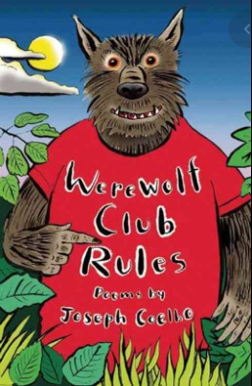  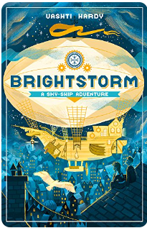  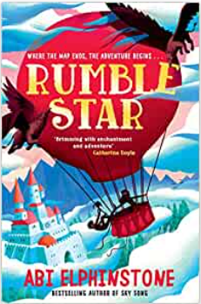  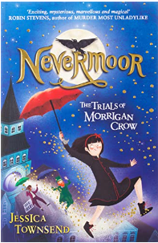  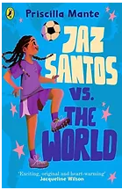  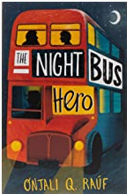  The Day I Fell into a Fairytale, Ben Miller  The Boy Who Made the World Disappear, Ben Miller  1,000 Year Old Boy, Ross Welford  Ella on the Outside, Cath Howe  Iguana Boy Saves the World, James Bishop  Far From Home, Berlie Doherty  Let It Go (Frozen Twisted Tale), Jen Calonita  Hetty Feather, Jacqueline Wilson  Gaslight. Eloise Williams  Twelve Minutes to Midnight, Christopher Edge  The Jamie Drake Equation, Christopher Edge  George’s Secret Key to the Universe, Stephen Hawking  The Ship of Shadows, Maria Kuzniar  Young, Gifted and Black, Jamia Wilson  I Ate Sunshine for Breakfast, Michael Holland,Phillip Giordano  Roller Girl, Victoria Jamieson  Black Powder, Ally Sherrick  The Lost Thing, Shaun Tan  Cookie and the Most Annoying Boy in the World, Konnie Huq  Varmints, Helen Ward  Factopia, Kate Hale  The Incredible Record Smashers, Jenny Pearson  The House with Chicken Legs, Sophie Anderson  Dragon Mountain, Katie and Kevin Tsang  The Saga of Erik the Viking, Terry Jones  Riddle of the Runes, Janina Ramirez  A Viking Adventure (The Histronauts), Frances Durkin

