Welcome to the Foundation Stage

Dear Duty Bearers, September 2023

A huge welcome to everyone joining us this year at Langtoft. We hope you have enjoyed a wonderful summer and join us in looking forward to a fantastic year in the Foundation Stage!

Marvellous Me
Our first topic this year is ‘Marvellous Me’ where we will be encouraging the children to get to know each other and discuss their likes and dislikes. We want the children to understand how it feels to belong and to begin to understand each other’s similarities and differences. We will consider how our bodies have grown and changed since we were babies and get messy through drawing and painting our own portraits.
Autumn
We will be learning about seasonal changes through forest school and exploring our school grounds. We will go on an Autumn walk and look for signs of Autumn. The children will collect acorns, conkers and different coloured leaves to investigate. We would love to see what your child has collected outside school so feel free to send in your finds! We will also learn about hedgehogs and use clay to create our own.

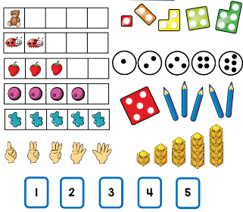
Mathematics
In maths the focus is on counting, recognising, writing and ordering numbers up to 5. The children will be saying which numbers are ‘more or less’ as well as estimating and checking amounts. We will be recognising, creating and describing shapes and patterns using mathematical language.

Phonics
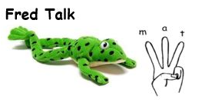
On Monday will begin to teach reading and writing through the phonics scheme Read Write Inc. New letter sounds will be introduced daily to the children and they will soon begin to recognise and write individual sounds and start to blend sounds together to read short words.

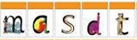
The children will be given the opportunity to practise these sounds at home. A pack of five sound sheets will be sent home each Friday. Please look at these with your child and help them recognise the sounds. They can have a go at writing them too.

If you have time (and you feel that your child is ready) you could also help your child to practise writing their name using the correct letter formation. Try to encourage them to hold their pencil correctly so that it becomes a natural habit and makes writing feel more comfortable for them. At school we say ‘Remember to use your pinchy fingers’.

Your child will also bring home a picture book from the book corner that they have chosen to share with you. There will be a set day that we change your child’s book during the week. Please write in your child’s Home School Record when they have read with you or practised their sounds.

Can you help us?
There are many valuable ways in which you can ‘get involved’ and contribute during your child’s time at Langtoft Primary School. Here are just a few that you may be interested in:
- Joining F.O.L.S. (Friends of Langtoft School) and helping to raise funds to benefit the children in the school.
- Donating unwanted toys, craft items and books in good condition.
- Becoming a Reading Buddy where you listen to children read and help them develop a positive attitude to reading.
Thank you in advance.
Please come and speak to one of us if you have any expertise or links to the topics we are doing throughout the year and would like to share these with the children.

Tapestry: Wow Moments and Observations

We encourage you to contribute to your child’s online journal on Tapestry. You can download the App on your phone or tablet as well as accessing it on a computer or laptop. You can add your own observations about what your child has been doing at home. This can be about anything you feel is relevant e.g. growing tomatoes, recognising numbers on a puzzle, making words with magnetic letters on the fridge, discussing a book from the library, collecting conkers in the woods, doing the monkey bars in the park, baking cakes, the list is endless! We love to see what your child has been doing at home and it gives us an insight into what they can do and what their interests are. If you have any questions regarding Tapestry please just ask.

Home time
We dismiss the children one at a time and the children know not to run off to parents without our permission. It helps if you give us a little wave so we know you are looking when your child is walking towards you. If someone else is due to collect your child please let one of the Foundation Stage team know, either verbally or by writing a note in your child’s reading diary (or contact the school office).

Photograph
Finally, as part of our ‘Marvellous Me’ topic we would like each child to bring in a photo of when they were younger to share and talk about how they have grown and changed. The photo could be a print out or you can upload one onto Tapestry.

Phonics Workshop Part 1 - Tuesday 19th September at 3.30pm
You are invited to attend a short session in the hall where you will be given an overview of how we begin to teach reading in Reception. You will learn how to say Set 1 sounds ‘purely’ so that you can support your child’s learning. We will explain reading at school and how you can support at home with this too.

Thank you for your support. We hope that you and your child have a great first term. Please do not hesitate to come and see us with any queries or concerns, no matter how small.

Mrs Ellis, Mrs Hudson and Mrs Nickson

